**Bryant PTSA meeting minutes**

**December 13, 2022**

|  |  |  |
| --- | --- | --- |
| **Time** | **Item** | **Owner** |
| 7:00 | **Welcome to December’s General Membership Meeting!**   * Run through agenda | President |
| 7:05 | **Standard Announcements**   1. **Approval of November 8th Minutes:** Motioned by Kathy, seconded by Meaghan. Approved as submitted 2. **Land Acknowledgement** 3. **Anti-Racist Commitment**  * Ensuring that we are following through on our anti-racist commitment. * Each month teachers have a race and equity issue we focus on in the classrooms, the PTSA could align with us. Speakers would be great for families * This month’s theme: Human Rights Day which is December 10th which is based on the Declaration of Human Rights. Education is a Human Right. * Co-secretaries in charge of Anti-Racist Commitment in January. | President/Vice President |
| 7:10 | **Principal Updates**   * Multicultural Night was a success, plan for next year 12/7/23 * Snow day plan * New social worker, Diego, has started (alt W, Thurs, Fri) – Families in Need, 504s, hunger prevention and student behavior support * Islandwood has more grants available and Mr. Garhlid will reapply to see if we can receive more. * Bryant Open House will be 1/26 from 5:30 - 7pm   + Lead for outreach? Flyer? Facebook? Preschools in neighborhood?   + Eliza will lead volunteers for tour   + PTSA rep (either Mary or Carrie) will speak alongside Kevin Gallagher * SPS Budget shortfall projections:   + Lead to engage and inform community on this issue?   + Idea? SPS speaker at March membership meeting * Heads up for treasures:   + Overtime requests handled by the school   + Taiko Drummers have been paid | President / Vice President |
| 7:20 | **Treasurer Update**   * David has updated the website forms (check request and deposit) which are posted on the front page of bryantschool.org * There is now a hyperlink to the budget within each monthly meeting on the Bryant website (next to minutes) * Millie Hobson will serve as Bryant Auction Lead * David to create restricted account for 5th grade activities | Treasurers |
| 7:25 | **Laser Update**   * They are currently interviewing new Executive Director and board directors. * They still have spots have winter break spots. |  |
| 7:30 | **Teacher’s Update**   * All are preparing for winter break and possible snow days. * Staff are re-evaluating what to do related to land acknowledgement. * Staff also preparing for BLM week (more like a month as there is time leading up). |  |
| 7:35 | **Volunteer Committee**   * Online Auction Volunteers   + 4 people expressed interest - they’ve been emailed   + Looking for a LEAD * Blast Auction Volunteers   + 15 people expressed interest - they’ve been emailed   + Looking for a LEAD * Lunch/Recess Volunteers * K Open House Volunteers (1/26) |  |
| 7:45 | **Other New Business**   * Librarian position funding * Bryant Community Volunteer Engagement   + Proposes Call to action – WE NEED YOU   + Bryant Way – Families need to all find ways they can help take care of our community * ASE updates   + New opportunities Jump On languages   + Share contract options with Clive and Elaine * Cotton Candy Machine – motion to buy from unallocated funds (Meaghan) and Mary seconded. | President/Vice President |
| 8:55 | **Advocacy Committee Update**   * PTSA Letter to School Board Director Hampson   + 252 Parents Formally signed letter | Kathy Austin/Carrie Lee |
| 9:09 | **Community Engagement and Events**   * Parent Night Out Update   + K and 1st PNO had strong attendance. 3nd wasn’t as popular. 2nd and 4/5 events are coming up.   + People expressed positive support for it being broken down by grade levels but time of year not ideal.   + May consider another round of PNOs in the spring. * Looking Ahead:   + January 2023 MLK Service Project   + Spring 2023 Art and Science Nights |  |
| 9:09 | **Adjourn**   * David moved to adjourn, Meaghan seconded. |  |

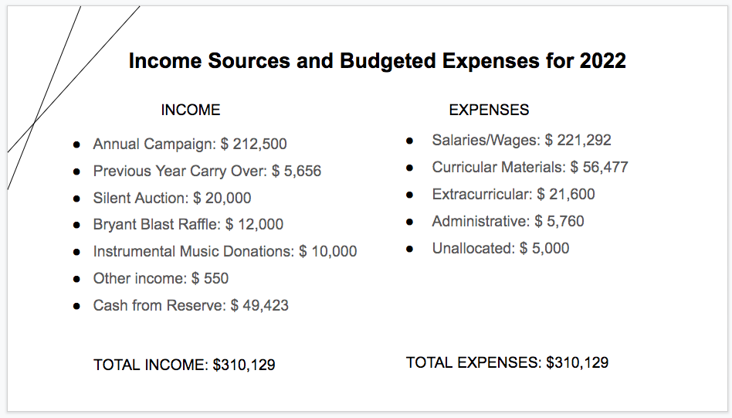

Action Items:

* Check with Amy to see if Multicultural Night next year is 12/7/23. Need to budget this in for next year as a line item.
* Carrie to check with FIN chair to see if she has connected with Diego, new Social Worker
* Sara to talk with Mo to organize flyer distribution for Bryant Open House
* David to create excel file where members can make notes about committee costs
* Sara to check in with Amy in the office to see if they support shortening assigned shifts for recess help and if they are in support, will change this in sign-up genius
* Community engagement chairs and volunteer chairs to write messaging asking for more volunteers